Uher Assignment 1
Michael Uher
2026-09-19
Opening the data retrieved from MAVEN ANALYTICS at https://mavenanalytics.io/data-playground/apple-s-greenhouse-gas-emissions
library(readxl)
greenhouse_gas_emissions <- read_excel("C:/Users/Mike/Downloads/Apple+Emissions/apple_emissions/greenhouse_gas_emissions.xlsx")
View(greenhouse_gas_emissions)
Showcasing descriptive statistics for both the quantitative variable of “Emissions” as well as the qualitative variables “Category” and “Type” using the summary and table commands
summary(greenhouse_gas_emissions$Emissions)
## Min. 1st Qu. Median Mean 3rd Qu. Max. NAs
## -500000 0 36250 1934613 300000 29600000 27
table(greenhouse_gas_emissions$Category)
##
## Corporate emissions Product life cycle emissions
## 96 40
table(greenhouse_gas_emissions$Type)
##
## Carbon removals Gross emissions
## 16 120
Transforming the “Emissions” variable by dividing it by 1000, creating the variable “Emissions_in_Thousands” to make the large numbers easier to view
greenhouse_gas_emissions$Emissions_in_thousands = greenhouse_gas_emissions$Emissions/1000
head(greenhouse_gas_emissions$Emissions_in_thousands)
## [1] 39.7 12.6 2.9 0.0 3.0 113.5
Plotting the variables “Fiscal Year” and “Emissions_in_thousands” in a histogram titled “Distribution of Emissions”. “Emissions_in_thousands” was used for an easier to view graph.
hist(greenhouse_gas_emissions$Emissions_in_thousands,main = "Distribution of Emissions",xlab = "Emissions(in thousands)",ylab = "Frequency")
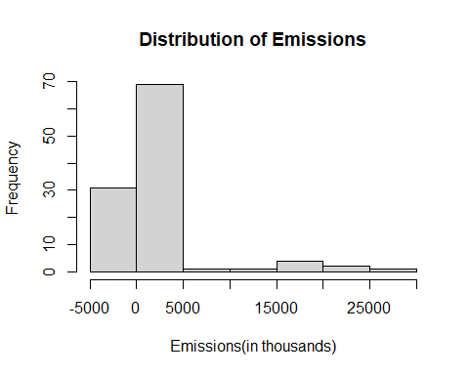
Plotting the variables “Emissions_in_thousands” and “Fiscal Year” into a scatter plot titled “Emissions per Year”.
plot(greenhouse_gas_emissions$`Fiscal Year`,greenhouse_gas_emissions$Emissions_in_thousands, main = "Emissions per Year",xlab = "Fiscal Year", ylab = "Emissions (in thousands)")
